Python Programs for Customer Purchase Behavior Analysis
Programs
Program 1: Load Dataset and Preview
import pandas as pd
file_path = "shopping_trends.csv"
df = pd.read_csv(file_path)
print("Dataset loaded successfully")
print(df.head())
print("Shape:", df.shape)
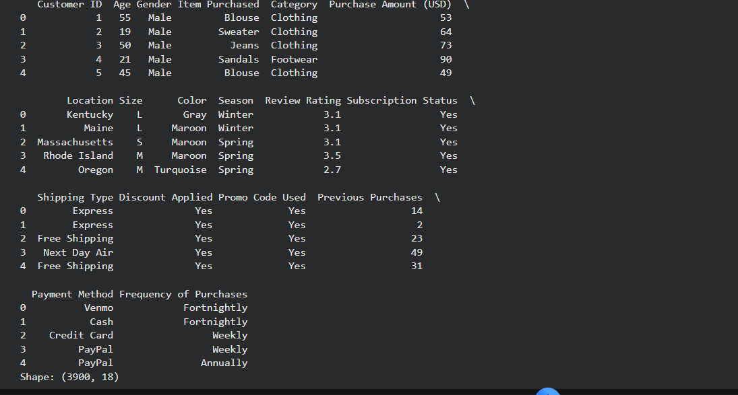
Program 2: Display Column Names
import pandas as pd
df = pd.read_csv("shopping_trends.csv")
print("Column names in dataset:")
for col in df.columns:
print(col)
print("Total columns:", len(df.columns))
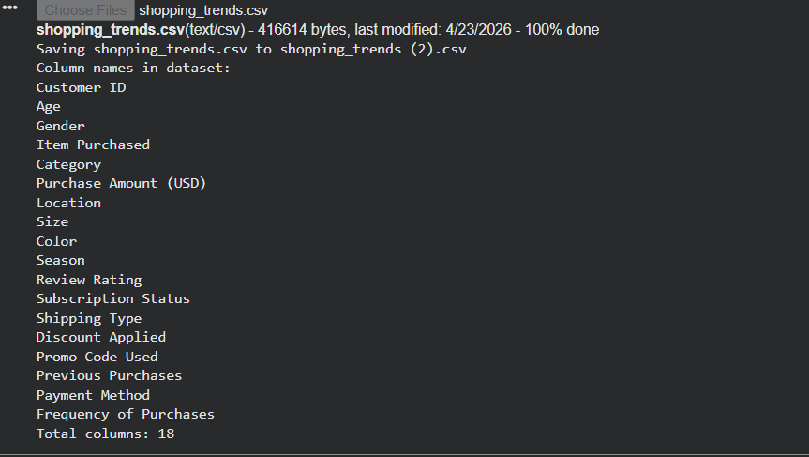
Program 3: Check Missing Values
import pandas as pd
df = pd.read_csv("shopping_trends.csv")
missing = df.isnull().sum()
print("Missing values per column:")
print(missing)
print("Total missing:", missing.sum())
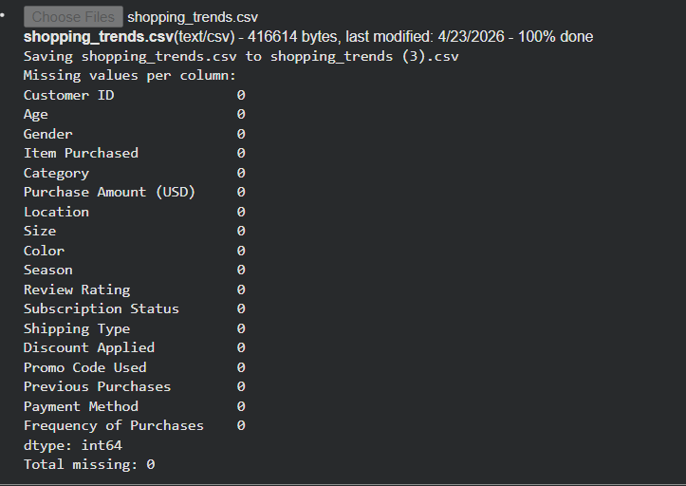
Program 4: Remove Duplicate Rows
import pandas as pd
df = pd.read_csv("shopping_trends.csv")
before = len(df)
df = df.drop_duplicates()
after = len(df)
print("Rows before:", before)
print("Rows after:", after)
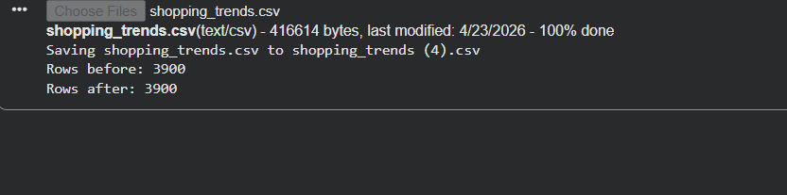
Program 5: Normalize Column Names
import pandas as pd
df = pd.read_csv("shopping_trends.csv")
df.columns = df.columns.str.strip().str.lower()
print("Normalized column names:")
print(df.columns)
print(df.head())
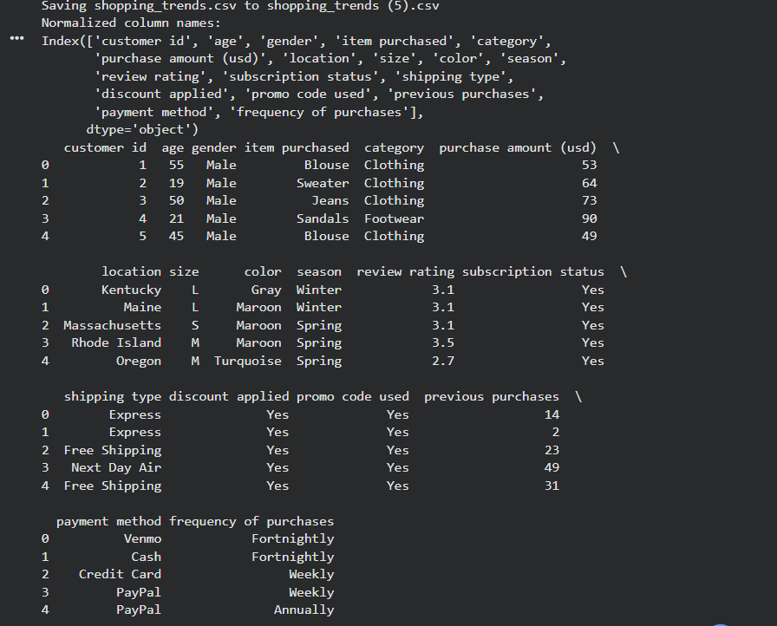
Program 6: Descriptive Statistics
import pandas as pd
df = pd.read_csv("shopping_trends.csv")
print("Descriptive statistics:")
print(df.describe())
mean_val = df['Purchase Amount (USD)'].mean()
print("Mean purchase amount:", mean_val)
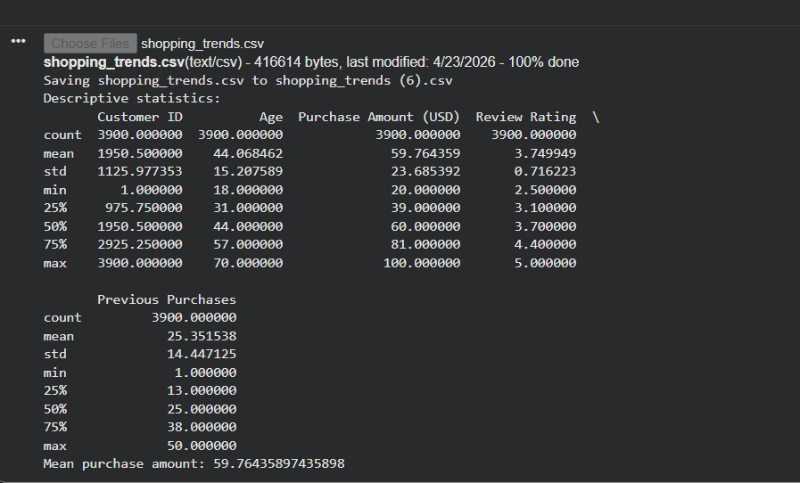
Program 7: Top Products Analysis
import pandas as pd
df = pd.read_csv("shopping_trends.csv")
top_items = df['Item Purchased'].value_counts().head(5)
print("Top 5 products:")
print(top_items)
for item, count in top_items.items():
print(item, "->", count)
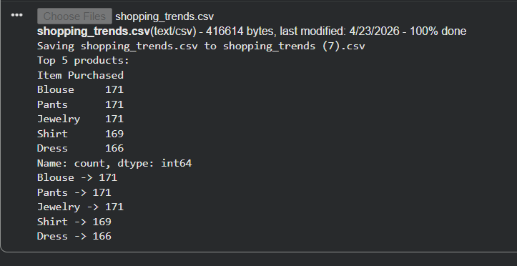
Program 8: Category Distribution
import pandas as pd
df = pd.read_csv("shopping_trends.csv")
category_counts = df['Category'].value_counts()
print("Category distribution:")
print(category_counts)
print("Total categories:", len(category_counts))
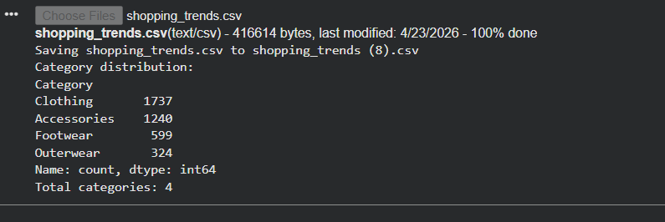
Program 9: Gender-wise Spending
import pandas as pd
df = pd.read_csv("shopping_trends.csv")
gender_spend = df.groupby('Gender')['Purchase Amount (USD)'].mean()
print("Average spending by gender:")
print(gender_spend)
print("Analysis complete")
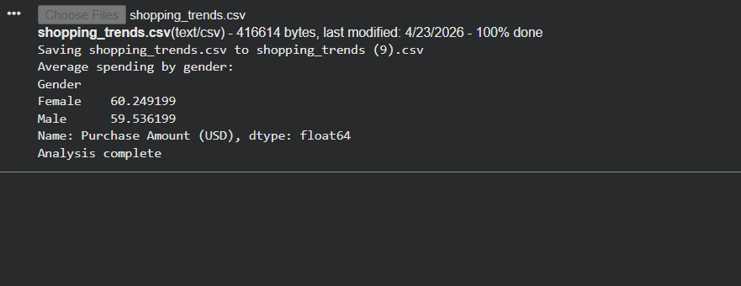
Program 10: Seasonal Spending Analysis
import pandas as pd
df = pd.read_csv("shopping_trends.csv")
season_avg = df.groupby('Season')['Purchase Amount (USD)'].mean()
print("Average spend by season:")
print(season_avg)
print("Highest season:", season_avg.idxmax())
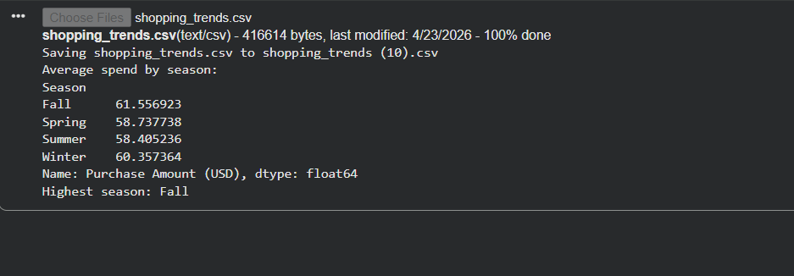
Program 11: Location-wise Sales
import pandas as pd
df = pd.read_csv("shopping_trends.csv")
location_sales = df.groupby('Location')['Purchase Amount (USD)'].sum()
print("Top locations by sales:")
print(location_sales.sort_values(ascending=False).head())
print("Done")
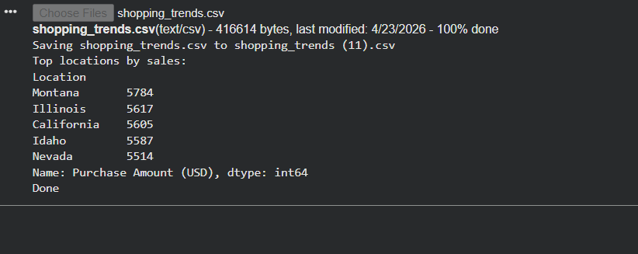
Program 12: Payment Method Analysis
import pandas as pd
df = pd.read_csv("shopping_trends.csv")
payment_avg = df.groupby('Payment Method')['Purchase Amount (USD)'].mean()
print("Payment method analysis:")
print(payment_avg)
print("Best method:", payment_avg.idxmax())
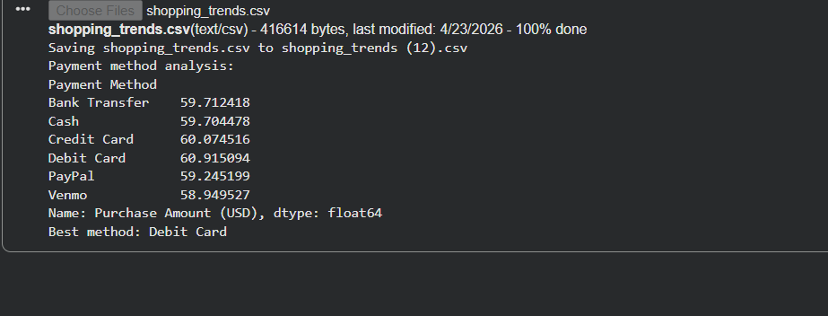
Program 13: Frequency Mapping
import pandas as pd
df = pd.read_csv("shopping_trends.csv")
freq_map = {'Weekly': 52, 'Monthly': 12, 'Quarterly': 4}
df['Freq_Num'] = df['Frequency of Purchases'].map(freq_map)
print(df[['Frequency of Purchases', 'Freq_Num']].head())
print("Mapping completed")
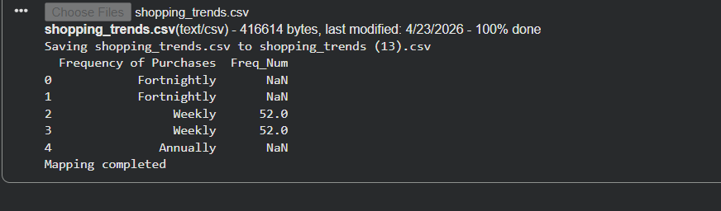
Program 14: Annual Spend Calculation
import pandas as pd
df = pd.read_csv("shopping_trends.csv")
freq_map = {'Weekly': 52, 'Monthly': 12}
df['Freq_Num'] = df['Frequency of Purchases'].map(freq_map)
df['Annual Spend'] = df['Purchase Amount (USD)'] * df['Freq_Num']
print(df[['Annual Spend']].head())
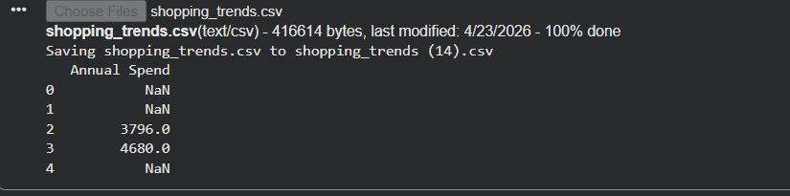
Program 15: Customer Segmentation
import pandas as pd
df = pd.read_csv("shopping_trends.csv")
def segment(x):
if x > 2000:
return "High"
elif x > 1000:
return "Medium"
else:
return "Low"
df['Segment'] = df['Purchase Amount (USD)'].apply(segment)
print(df['Segment'].value_counts())
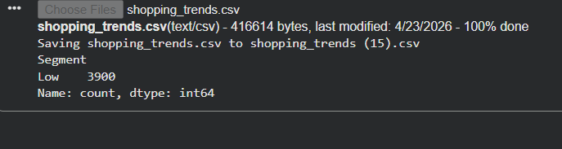
Program 16: Age Group Creation
import pandas as pd
df = pd.read_csv("shopping_trends.csv")
df['Age Group'] = pd.cut(df['Age'],
bins=[18,25,35,50,60],
labels=['18-25','26-35','36-50','50+'])
print(df[['Age','Age Group']].head())
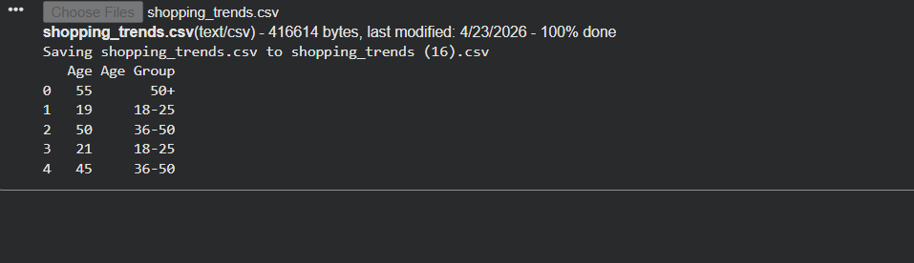
Program 17: Bar Chart for Top Items
import pandas as pd
import matplotlib.pyplot as plt
df = pd.read_csv("shopping_trends.csv")
top = df['Item Purchased'].value_counts().head(5)
top.plot(kind='bar')
plt.title("Top Items")
plt.show()
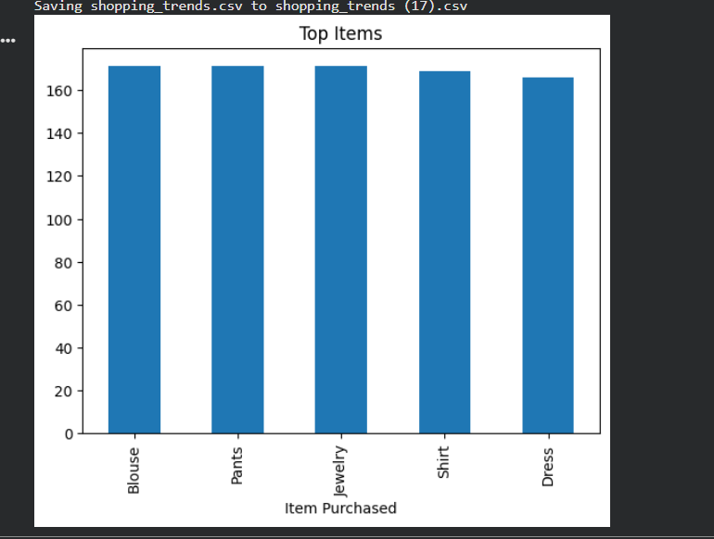
Program 18: Pie Chart for Category Share
import pandas as pd
import matplotlib.pyplot as plt
df = pd.read_csv("shopping_trends.csv")
df['Category'].value_counts().plot(kind='pie', autopct='%1.1f%%')
plt.title("Category Share")
plt.show()
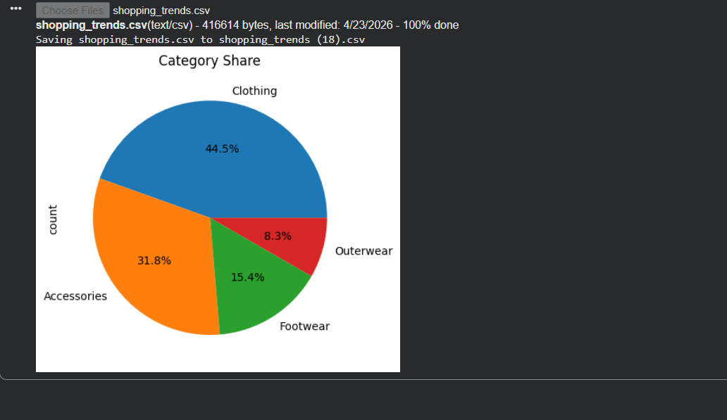
Program 19: Histogram for Age Distribution
import pandas as pd
import matplotlib.pyplot as plt
df = pd.read_csv("shopping_trends.csv")
df['Age'].hist()
plt.title("Age Distribution")
plt.show()
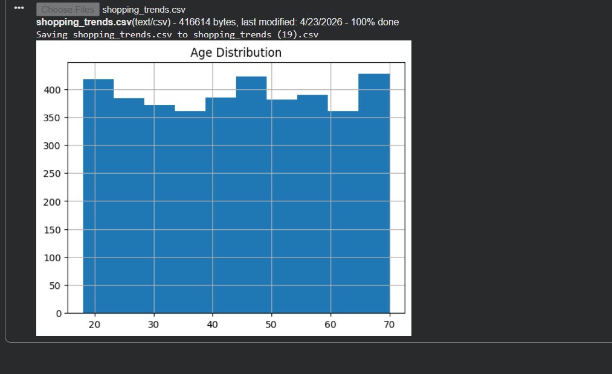
Program 20: Export Cleaned Dataset
import pandas as pd
df = pd.read_csv("shopping_trends.csv")
df = df.drop_duplicates()
df.to_csv("cleaned_data.csv", index=False)
print("Cleaned file exported successfully")
